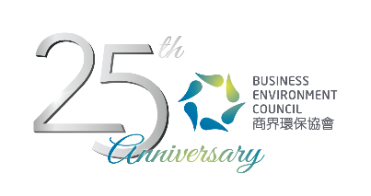
Credit Card Payment Form
Low Carbon HK: the Leadership Challenge
How to Go about Influencing your Company to set Carbon Reduction Targets?
Workshop for Sustainability Managers & Officers

Date: | 16 March 2017 (Thursday) 2:15pm – 5:15pm
Venue: | BEC Room 202E, 2/F, 77 Tat Chee Avenue, Kowloon Tong
Fee: | BEC Members: HK$200 per person  Non-BEC Members: HK$300 per person
Please complete this form and email to jill@bec.org.hk. For any inquiries, please contact Ms Jill Chow (T. 2784 3942 | E. jill@bec.org.hk).
Name of the Participant
Organisation:

By Credit Card VISA MasterCard AmEx
Payable to: Business Environment Council Limited
Cardholder: |  | Amount (HK$)
Card No: |  | Expiry Date:
Signature: |  | Date:

