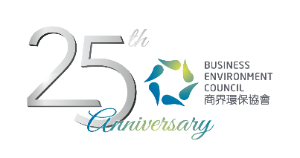
Credit Card Payment Form
CIRCULAB Discovery

Date: | Workshop I:  1 June 2017 (Thursday) 9:00am – 11:00am  Workshop II:  9 June 2017 (Friday) 9:00am – 11:00am  (Please indicate your choice with a tick “✓” in the appropriate box.)
Venue: | BEC Room 202C, 2/F, 77 Tat Chee Avenue, Kowloon Tong
Fee: | BEC Members: HK$200 per person  Non-BEC Members: HK$300 per person
Please complete this form and email to jill@bec.org.hk. For any inquiries, please contact Ms Jill Chow (T. 2784 3942 | E. jill@bec.org.hk).
Name of the Participant
Organisation:

By Credit Card VISA MasterCard AmEx
Payable to: Business Environment Council Limited
Cardholder: |  | Amount (HK$)
Card No: |  | Expiry Date:
Signature: |  | Date:

