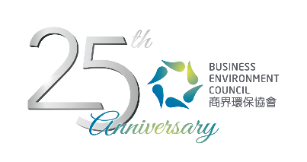
Credit Card Payment Form
Energy Efficiency Technologies Mini-Expo and Seminar: Energy Savings for Hotel and F&B Sectors

Date: | 12 June 2017 (Monday) 1:30pm – 6:00pm
Venue: | BEC Exhibition Hall and Auditorium, G/F, 77 Tat Chee Avenue, Kowloon Tong
Fee: | BEC Members: Free  Non-BEC Members: HK$200 per person  Members of Supporting Organisation: HK$100
Please complete this form and email to katelam@bec.org.hk. For any inquiries, please contact Ms Kate Lam (T. 2784 3958 | E. katelam@bec.org.hk).
Name of the Participant
Organisation:

By Credit Card VISA MasterCard AmEx
Payable to: Business Environment Council Limited
Cardholder: |  | Amount (HK$)
Card No: |  | Expiry Date:
Signature: |  | Date:

