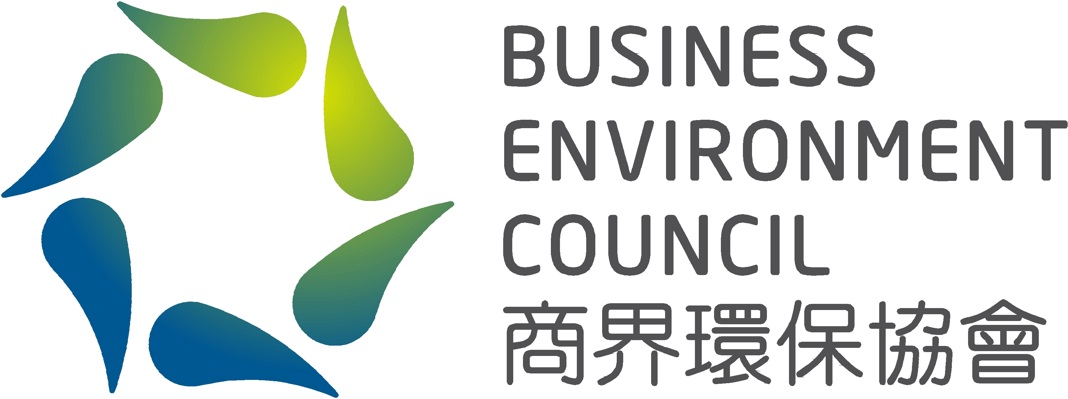 | Credit Card Payment Form  BEC EnviroSeries Conference 2018 Nov

Date: | 23 November 2018 (Friday)
Venue: | The Mira Hong Kong
Fee: | Standard Registration Fee: HK$1,800 per head  - Council Members: HK$ 1,440 per head (20% discount)  - Corporate Members: HK$ 1,530 per head (15% discount)  - General Members: HK$ 1,620 per head (10% discount)  - Affiliate Members: HK$ 1,620 per head (10% discount)  Early Bird Discount** (Registration on or before 5 November 2018):  - BEC members: HK$1,080 per head (40% discount)  - Non-BEC members: HK$1,260 per head (30% discount)  Group Discount** (3 or more participants registered at the same time):  - BEC members: HK$1,080 per head (40% discount)  - Non-BEC members: HK$1,260 per head (30% discount)  **Discount cannot be used in conjunction with any other discounts.
Please complete this form and email to shaniacheng@bec.org.hk. For any inquiries, please contact Shania Cheng (T. 2784 3958 | E. shaniacheng@bec.org.hk).

Name of the Participant 1:
Organisation:
Name of the Participant 2:
Organisation:
Name of the Participant 3:
Organisation:

By Credit Card VISA MasterCard AmEx

Payable to: Business Environment Council Limited
Cardholder: |  | Amount (HK$)
Card No: |  | Expiry Date:
Signature: |  | Date:

